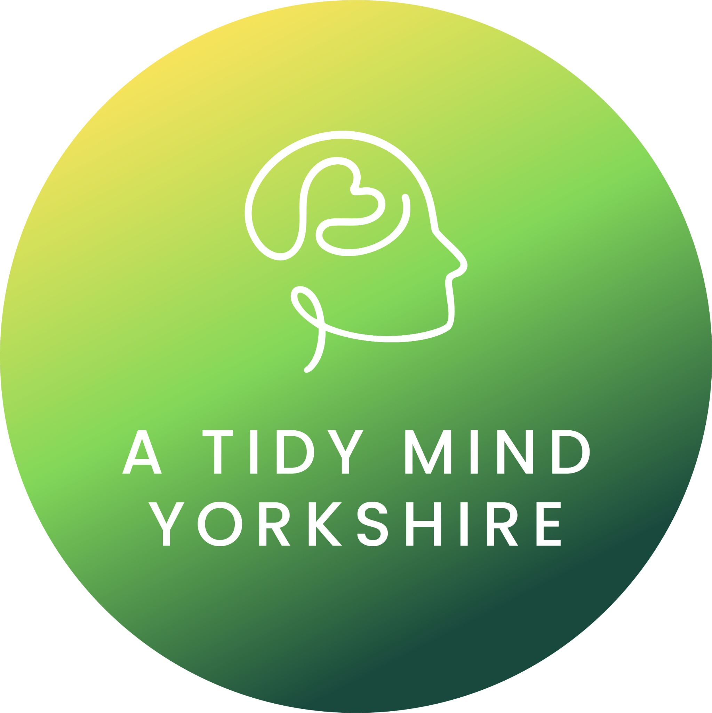

A Tidy Mind Yorkshire

ADHD Coaching Working Agreement
This working agreement outlines how we will work together in ADHD coaching. It is designed to create clarity, trust, and forward momentum while remaining flexible enough to work with real life and real brains.

1. Purpose of Coaching
ADHD coaching is a collaborative, strengths-based process focused on building practical systems that work for your brain, increasing self-awareness and self-trust, and supporting sustainable change.
Coaching is not therapy, counselling, or medical treatment and does not replace care from healthcare or mental health professionals.

2. Roles & Responsibilities
As Your Coach, A Tidy Mind Yorkshire Commits To:
• Providing a supportive, respectful, ADHD-informed space
• Using practical, evidence-informed tools and strategies
• Collaborating rather than directing or fixing
• Maintaining confidentiality and professional boundaries
• Adapting approaches to your needs and capacity
As the Client, You Commit To:
• Attending sessions as agreed
• Showing up as honestly as possible (including on challenging days)
• Engaging actively in sessions and agreed actions
• Communicating openly about what is and isn’t working
• Taking responsibility for decisions between sessions

3. Sessions & Structure
Sessions are typically 50 minutes and usually held weekly or fortnightly.
Sessions take place virtually via zoom.
Goals will be agreed collaboratively and reviewed regularly.

4. Communication Between Sessions
Between-session contact is limited to scheduling and agreed accountability check-ins.
Coaching does not provide crisis support.

5. Confidentiality
All information shared is confidential, except where disclosure is required by law (for example, if there is a risk of serious harm to yourself or others).

6. Boundaries & Scope
Coaching focuses on present and future-oriented change. If needs arise outside the scope of ADHD coaching, appropriate referrals may be discussed.
Either party may pause or end coaching with reasonable notice.

7. Cancellation & Rescheduling Policy
A minimum of 48 hours’ notice is required to cancel or rearrange a session.
Cancellations made more than 48 hours before the session will not be charged.
Cancellations made within 48 hours of the scheduled session time, or non-attendance without notice, will incur a 100% session fee.

8. Neurodiversity-Affirming Values
At A Tidy Mind Yorkshire, ADHD is viewed as a difference, not a deficit.
Compassion is prioritised over perfection, and progress is understood to be non-linear.
Systems are designed around capacity, not unrealistic expectations.

9. Agreement
This working agreement may be reviewed and adjusted as needed.

